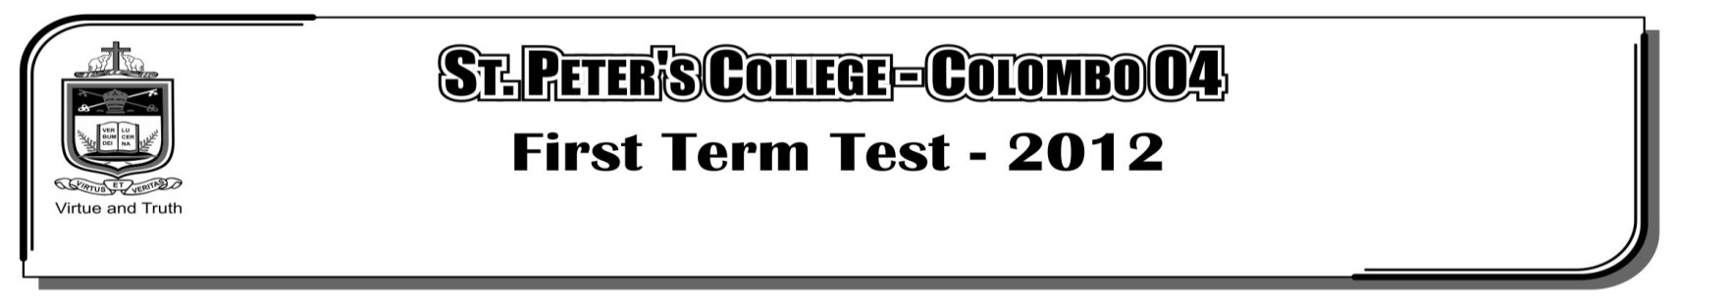

**SECOND TERM EXAMINATION - 2020**

**GRADE 10 – Health Science and Physical Education**

**Paper I**

01. Of all the stages in life, the physical changes can be clearly and quickly observed in,

i. In fancy ii. Childhood iii. Adolescence iv. Youth

**Answer 2 – 4 questions by using following chart.**

|  |  |
| --- | --- |
| **Student** | **Deficient nutrient** |
| **A** | Iron |
| **B** | Vitamin A |
| **C** | Iodine |

02. It can be assumed that out of these student/s who got Goiter is/are,

i. A ii. C iii. A and B iv. B and C

03. Of these students Amila cannot see in the weight. Amila is,

i. A ii. B iii. C iv. A or B

04. The student suffering Animia is/are,

i. A ii. C iii. B and C iv. A, B and C

05. The figure shows,

i. Menstruation Process ii. Ejaculation Process

iii. Fertilization Process iv. Ovulation Process

06. Letters A and B in the figure shows respectively,

i. Sperm and Ovum ii. Ovum and Sperm

iii. Zygote and Sperm iv. Zygote and Ovum

07. “I am the H.I.V. Virus. Find me the media that I can live in”,

i. Seminal Fluid ii. Vaginal Fluid

iii. Blood iv. All of the above media

08. “I” am made of soft tissues which make up the lungs. I play a major role in gas exchange during respiration. I am,

i. The trachea ii. The nose

iii. A capillary iv. An alveolus

09. Wesmi, who is suffering from protein calorie malnutrition,

1. Does not have the right weight for his height.
2. Has an enlarged thyroid gland.
3. Has a weak sight.

iv. Frequently urinates

10. Which of the following food item is poor in nutritive value,

i. Sambar ii. Fruit Salad

iii. Mixed vegetable curry iv. Sausages with Sauce

11. I am a virus that can live only in living cells. After entering your body, I can destroy your immune system. I am the,

i. Dengue Virus ii. H.I.V. Virus

iii. Herpes Virus iv. Human Papilloma Virus

12. **Body mass index (B.M.I.) of four students are given below**

A $→$ 17

B $→$ 21

C $→$ 25

D $→$ 30

Which of the above students are at a higher risk of developing conditions such as diabetes, increased blood cholesterol level and heart diseases.

i. A and C ii. B and C iii. B and D iv. C and D

13. What is the appendage that closes the larynx when swallowing food,

i. Trachea ii. Pharynx iii. Epiglotis iv. Pleura

14. Rama, who is suffering from wasting, often tends to have fights with the villages. He is devoted to his religion. The fields that cause disturbance to his well-being are,

i. Physical , Mental and Social ii. Mental , Spiritual and Social

iii. Physical , Spiritual and Mental iv. Physical , Mental , Social and Spiritual

15. My friend has the ability to manage stress and emotions accordingly, it can be stated that,

i. He has good physical health ii. He has good mental health

iii. He has good social health iv. He is a person with psycho-social well-being

**Use the following information to answer question 16 and 17.**

Sanduni, Who is frequently consuming large amount of fats. Sugar and salt, never engages in exercises.

16. The colour of the zone which Sanduni belongs in the Body Mass Index (B.M.I.) chart could most likely be,

i. Orange ii. Light Purple

iii. Green iv. Light Purple or Dark Purple

17. According to the above information, the disease condition that could most likely affect Sanduini is,

i. Appendicitis ii. Tuberculosis iii. Diabetes iv. Cirrhosis

18. For a successful growth, the zygote formed after an ovum being fertilized by a sperm must be deposited in the,

i. Ovary ii. Fallopian tube iii. Uterus iv. Cervix

19. The type of food rich in iron,

i. Sausages ii. Chicken iii. Nivithi iv. Eggs

20. The food item is consisting high cholesterol,

i. Chicken ii. Beef iii. Prawns iv. Fish

**Paper II**

**Answer only for 3 questions.**

01. i. What is the meaning of total health according to the world health organization?

ii. Write down 3 suitable life styles to maintain total health.

iii. Write down how to calculate Body Mass Index.

iv. According to the Asian measurements what is the normal level of B.M.I.

v. Write down 3 actions to be taken to overcome challenges faced in achieving total health.

02. i. Write down 5 stages in childhood.

ii. Write down 3 Psycho-social needs in infant stage.

iii. Write down 3 physical needs of early childhood.

1. Write down 3 activities that you can do within the school to develop the personality of a child during the late childhood.

v. Write down 2 psychological needs in late childhood.

03. i. Write down 3 symptoms can occur if a person has poor nutrition.

ii. Write down the 2 types of malnutrition.

iii. Write down 3 problems can get because of obesity.

iv. Write down 3 types of food rich in iron.

1. Write down 3 harmful effects of iron deficiency.

04. i. Write down 3 steps can be taken to prevent nutritional problems.

ii. Write down 3 harmful effects of iodine deficiency.

iii. Write down 2 prentive actions that can be taken to reduce iodine deficiency.

iv. Write down 3 advantages of growing vegetables and fruits in your own garden.

v. Write down 3 types of food popular in Tamil community and Muslim community separately.